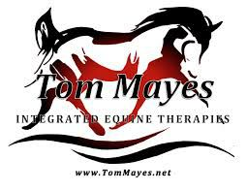
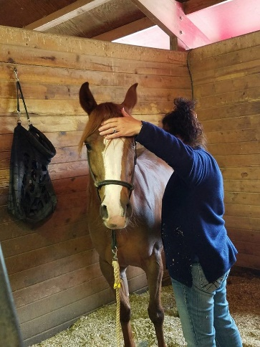
The Benefits of Hosting a Tom Mayes Clinic

- Horses Receive 2 to 4 Days of Hands On Therapy from Students
- Treatment Therapy Value - $100 - $700 - Per Horse
- Educational Insight
- Enlightenment
- Deeper Connection & Communication With Your Horse
- Better Range of Movement
- Balanced Body
- Improved Performance
- Connection With IET Students In Your Area
- Opportunity To Train For Yourself or Your Staff
Value of $459 - $659

